**GIT LAB ASSIGNMENT** ➔ **02**

NAME : SHOBNA SAMUKTHA RAJ S

BRANCH : B.E

DEPT : COMPUTER SCIENCE AND ENGINEERING

YEAR : IV - YEAR

COLLEGE : KSRIET

DATE : 12.07.2024

1. Create a new directory and change into it.

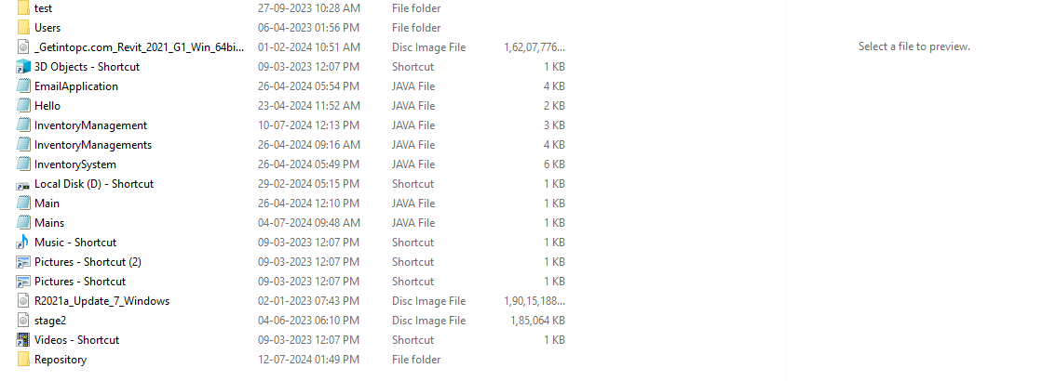

2. Use the **init** command to create a Git repository in that directory.

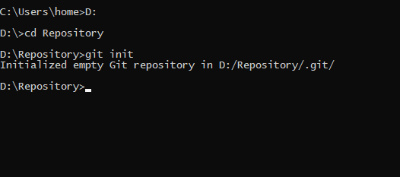

3. Observe that there is now a **.git** directory.

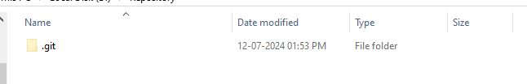

4. Create a **README** file.

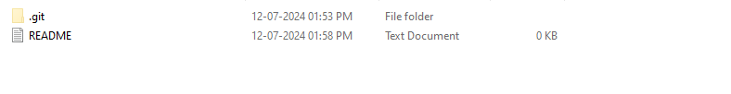

5. Look at the output of the **status** command; the **README** you created should appear as an untracked file.

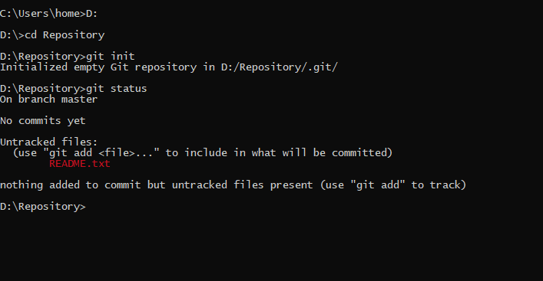

6. Use the **add** command to add the new file to the staging area. Again, look at the output of the **status** command.

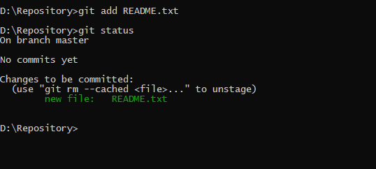

7. Now use the **commit** command to commit the contents of the staging area.

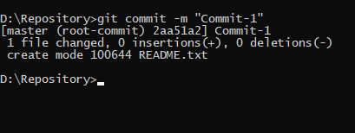

8. Create a **src** directory and add a couple of files to it.

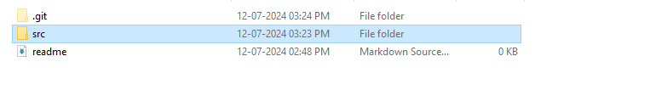

9. Use the **add** command, but name the directory, not the individual files. Use the **status** command. See how both files have been staged. Commit them.

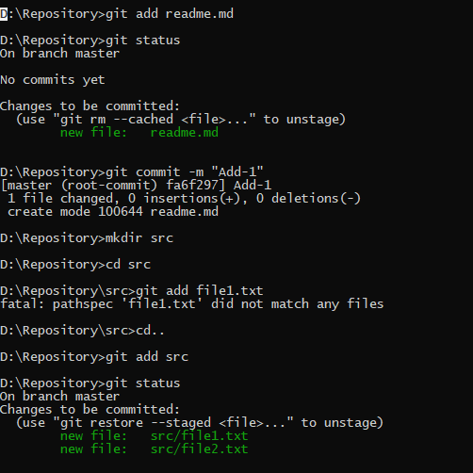

10. Make a change to one of the files. Use the **diff** command to view the details of the change.

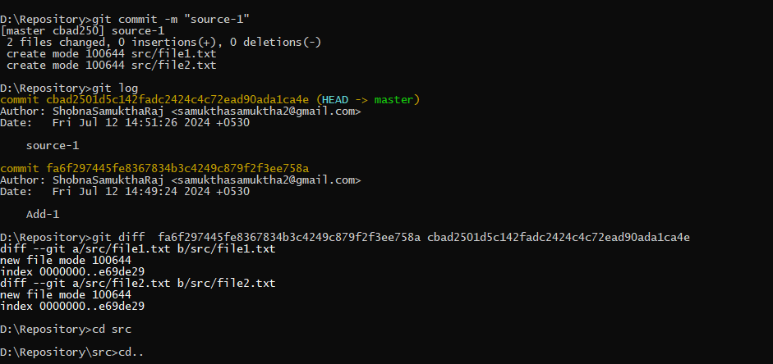

11. Next, **add** the changed file, and notice how it moves to the staging area in the **status** output. Also observe that the **diff** command you did before using add now gives no output. Why not? What do you have to do to see a **diff** of the things in the staging area? (Hint: review the slides if you can’t remember.)

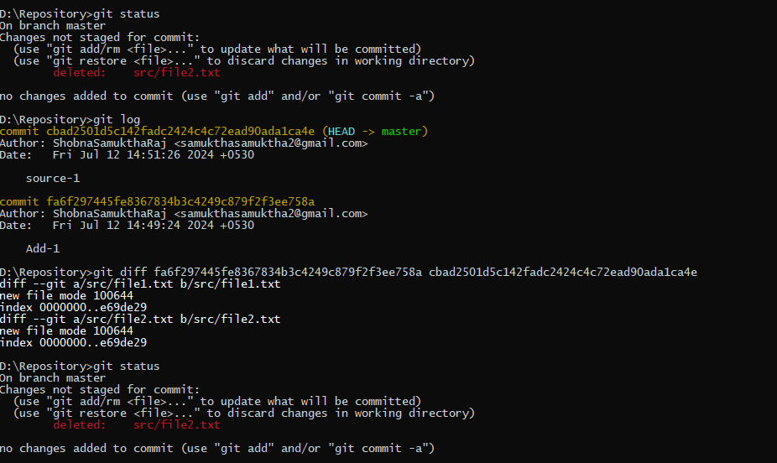

12. Now – without committing – make another change to the same file you changed in step 10. Look at the **status** output, and the **diff** output. Notice how you can have both staged and unstaged changes, even when you’re talking about a single file. Observe the difference when you use the **add** command to stage the latest round of changes. Finally, **commit** them. You should now have started to get a feel for the staging area.

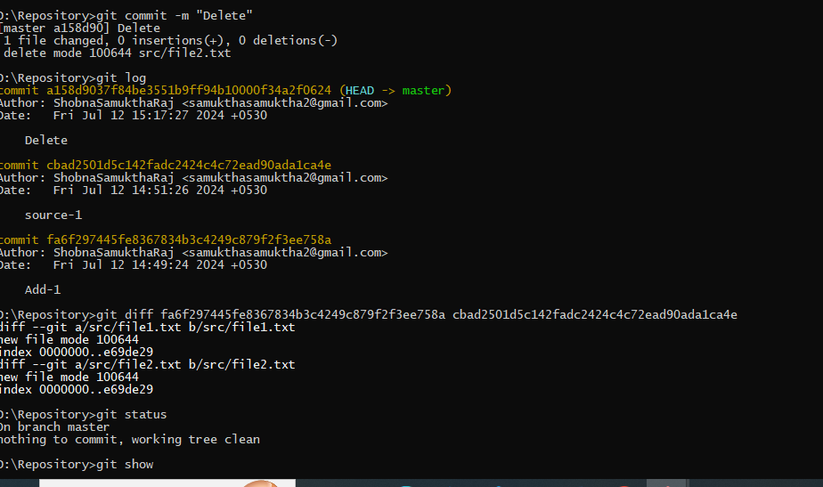

13. Use the **log** command in order to see all of the commits you made so far

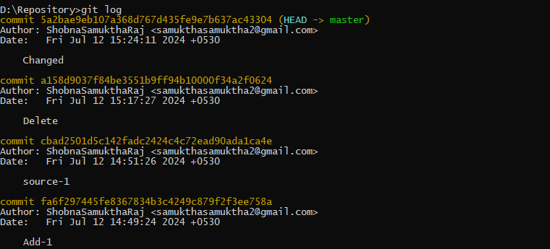

14. Use the **show** command to look at an individual commit. How many characters of the commit identifier can you get away with typing at a minimum?

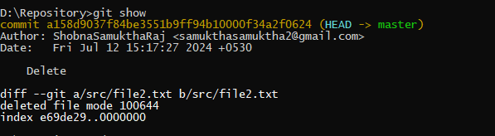

15. Make a couple more commits, at least one of which should add an extra file.



